1.Install the balenaEtcher software
Click balenaEtcher-2.1.4.Setup.exe to start the installation, then launch the software after installation
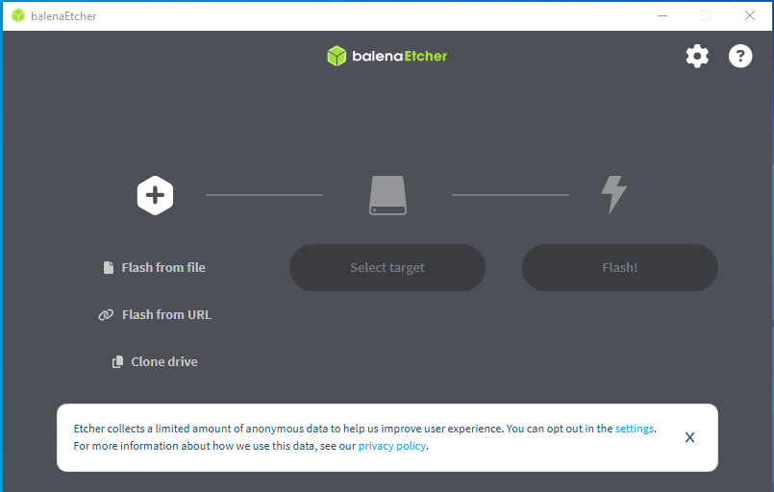

2. Insert the solid-state drive (SSD)
Required tool: SSD flasher enclosure (not provided separately, please prepare it yourself).
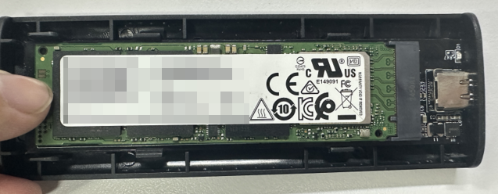
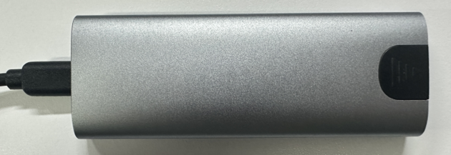

3. Follow the wizard to select the IMG file you need to flash
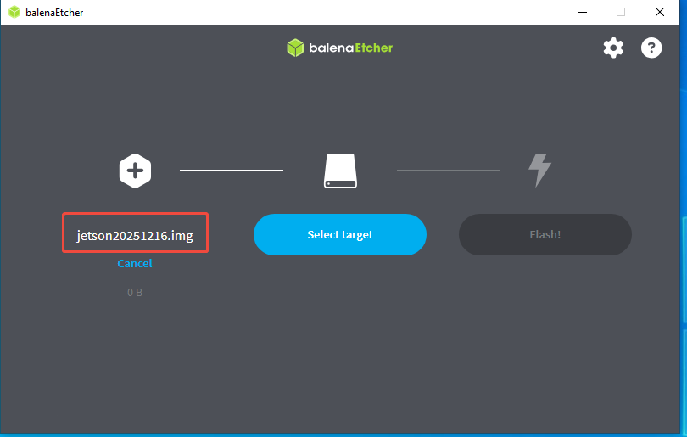

4.Select your solid-state drive (SSD)
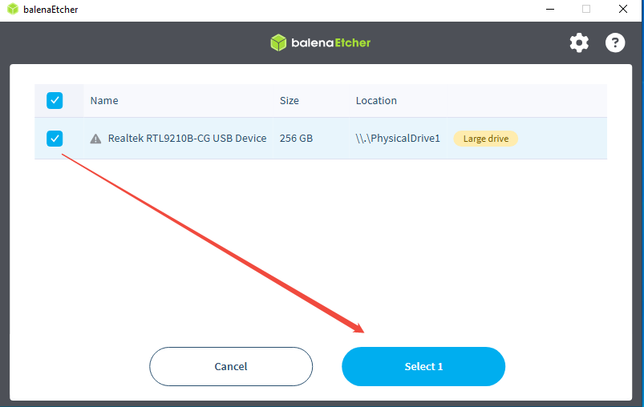

5.Click Flash.
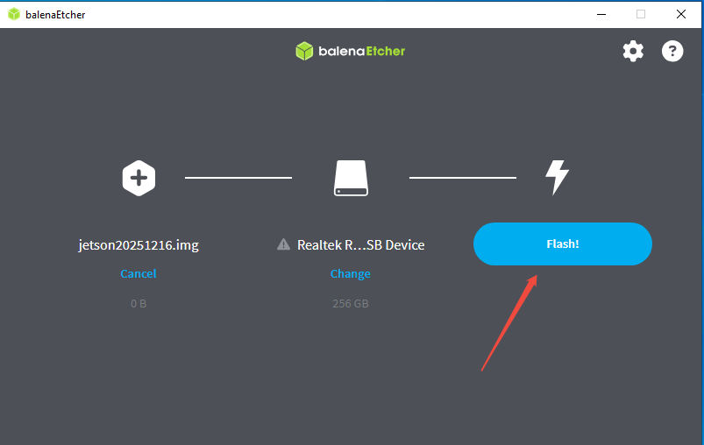

The above steps only flash the image file to your solid-state drive. Next, we need to modify the boot items, which requires the Ubuntu system. Please refer to the document Method for Setting Up the Jetson Virtual Machine Environment in the materials and set up the Ubuntu environment first.

6. Insert the solid-state drive (SSD) into the Ubuntu system
Enter the command lsblk to check the mounting status.
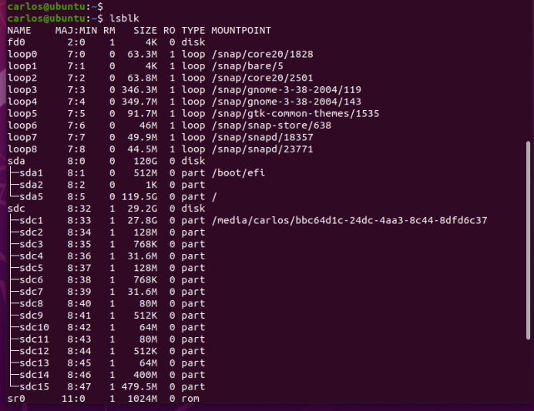

As can be seen from the figure above, the SSD is mounted to the drive letter sdc.
Next,Enter the command sudo mount /dev/sdc1 /mnt to mount the first partition sdc1 of sdc to the /mnt directory of the Ubuntu system.
Use the ls command to check, and you can see that the root directory of JP has been mounted under this directory.

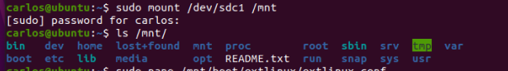

Enter the command: sudo blkid /dev/sdc1
query the PARTUUID.
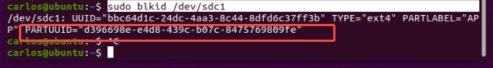
Finally: You need to modify the boot items.
Enter the following command sudo nano /mnt/boot/extlinux/extlinux.conf to open the boot configuration file.
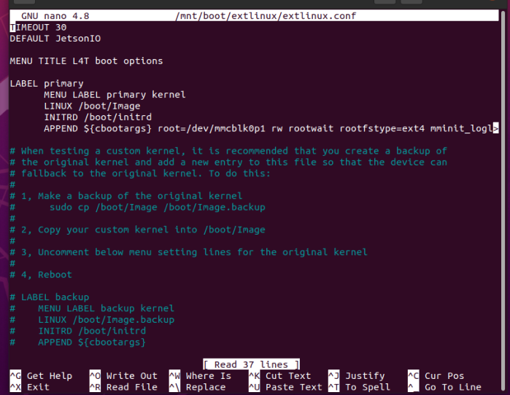

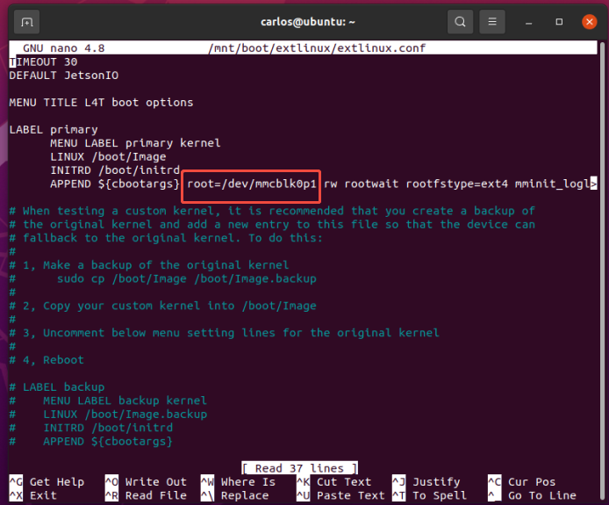

Make the following modifications:
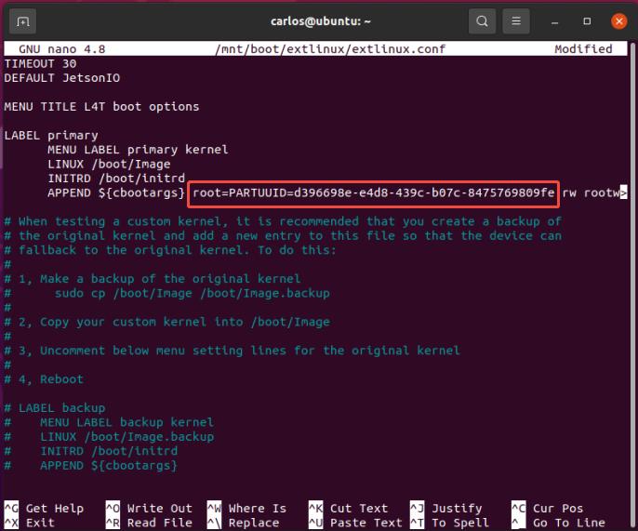

If the system image has been logged into before, you also need to modify the value of root below using the same method as above.
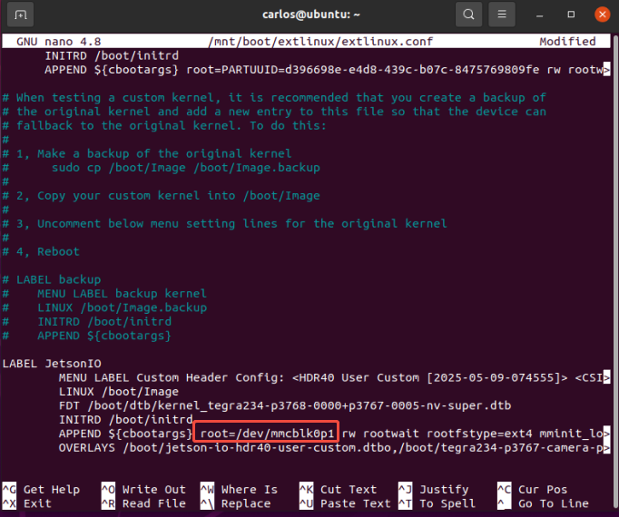

Note: Double-check for any typos, as incorrect entries will prevent the system from booting up.
The PARTUUID you enter should not be enclosed in quotation marks!!!
After confirming that everything is correct, press Ctrl+X, then enter y to save and exit.
Install the solid-state drive (SSD) into the Jetson device and power it on. The boot password is elecrow.

